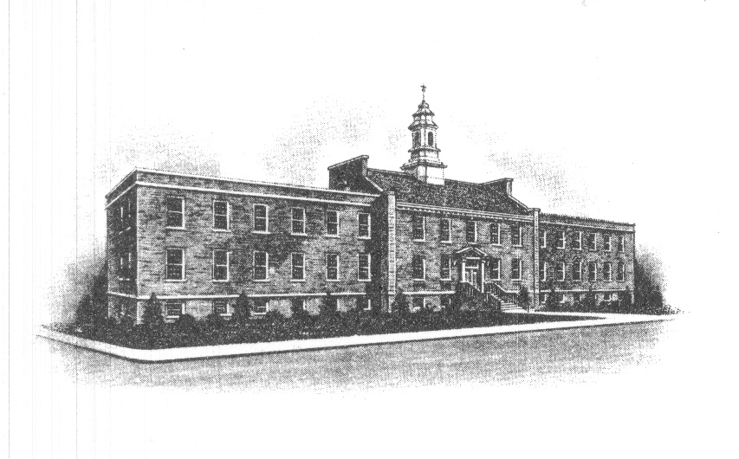
The Borough of Sayreville
Sayreville Board of Adjustment
167 Main Street
Sayreville, NJ 08872
(732) 390-7077 - Phone
(732) 390-7458 - Fax

SPECIAL MEETING ANNOUNCEMENT

Take notice that on Wednesday, May 2, 2018 at 7:30 PM, the Zoning Board of Adjustment in the Borough of Sayreville, N.J., will be holding a “Special” public meeting. FORMAL ACTION WILL BE TAKEN. The following matters are to be considered:

Application #16-13 by Shri Bhaktinidhi, Inc., for a Use Variance, Conditional Use Variances, Bulk Variances and Site Plan approval to construct a religious temple including 12 apartment/parsonage units and related improvements on the property located at 717 Washington Rd, Block 208, Lots 1.02 and 1.03.

The final agenda of the Board has not been determined and other matters may be scheduled and the Board may address and take action on other matters brought before it. The meeting will be held in the main Borough Hall, 167 Main Street, Sayreville, NJ 08872, in the Council Chambers on the third floor. This notice shall be filed in the office of the Municipal Clerk, will be posted on the Borough bulletin board, noticed in The Home News Tribune and Star Ledger newspapers. Any applications, maps and documents related to the above applications will be available for review in the Construction/Zoning Office located at 49 Dolan Street, Sayreville, NJ during normal working hours 7:30 AM – 4:00 PM.

Joan M. Kemble
Secretary
Zoning Board of Adjustment

